# ASSIGNMENT 3: A simple RESTFUL API using React.js, Database Creation, and Creating Index.

**Name: Bolla Hemalatha**

**Rollno: 20NN1A1272**

# E-Mail: bollahemalatha.ps@gmail.com

**College: Vignan’s Nirula Institute of Science and Technology for Women’s**

# Restful API code:

**Rest Output on Thunder Client:**

**This is the output when we create an API using REST.**

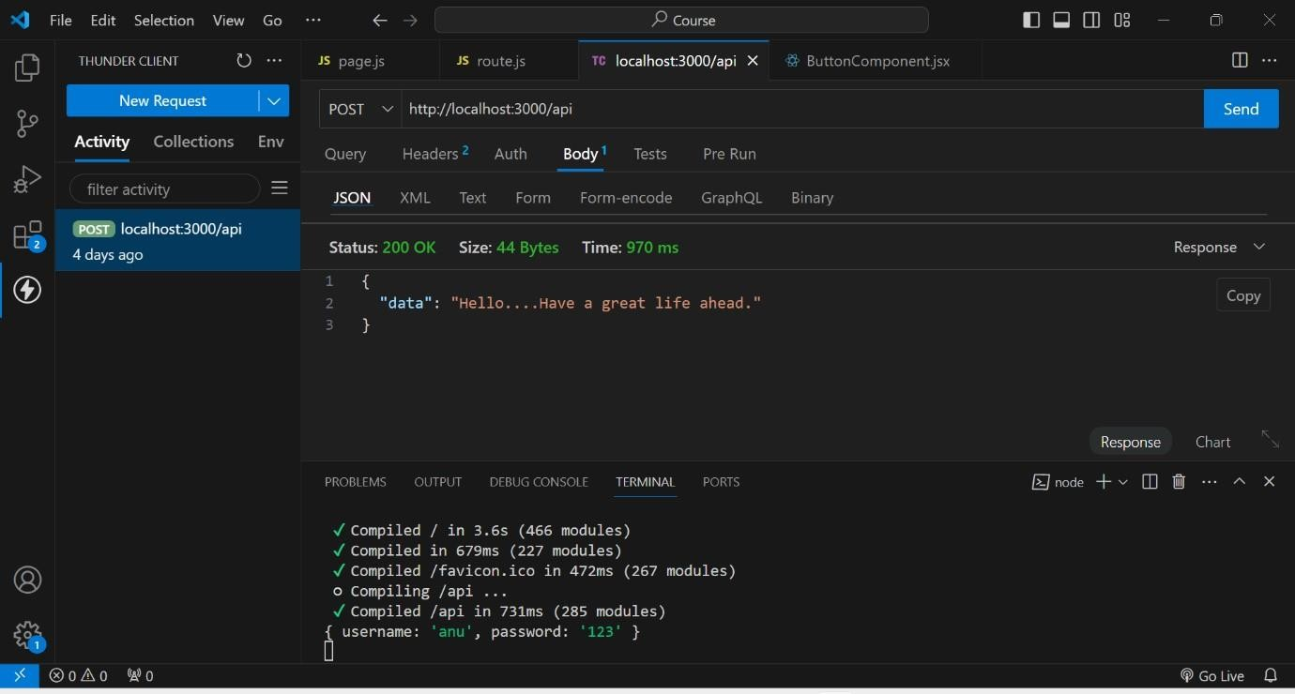

# DataBase Creation:

1st we created a database named test

In that test we created a collection named Students

And finally by using ADD DATA , we added data of the students like rno, name, age.

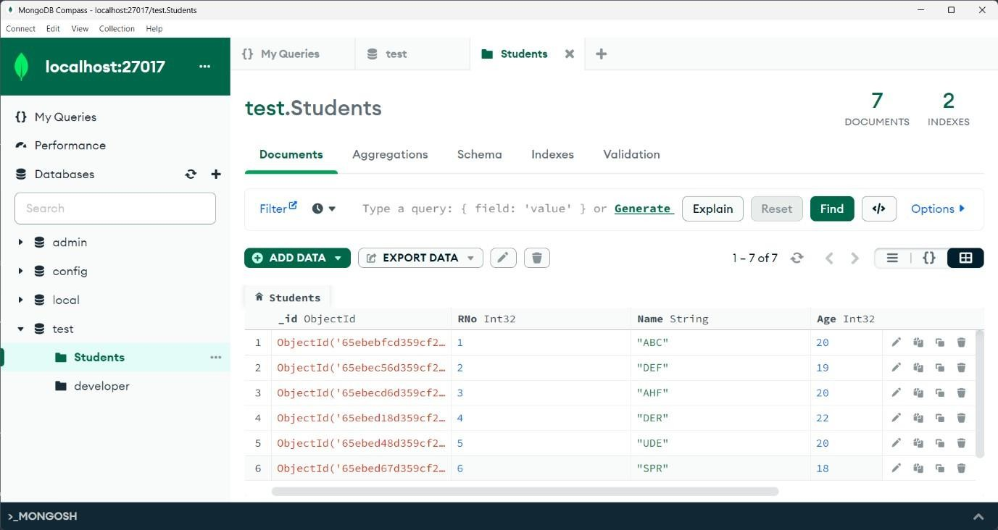

# Indexing Creation:

As rno is the unique attribute through which we identify a student uniquely. So, here I created an index based on rno. And assigned unique key to it.

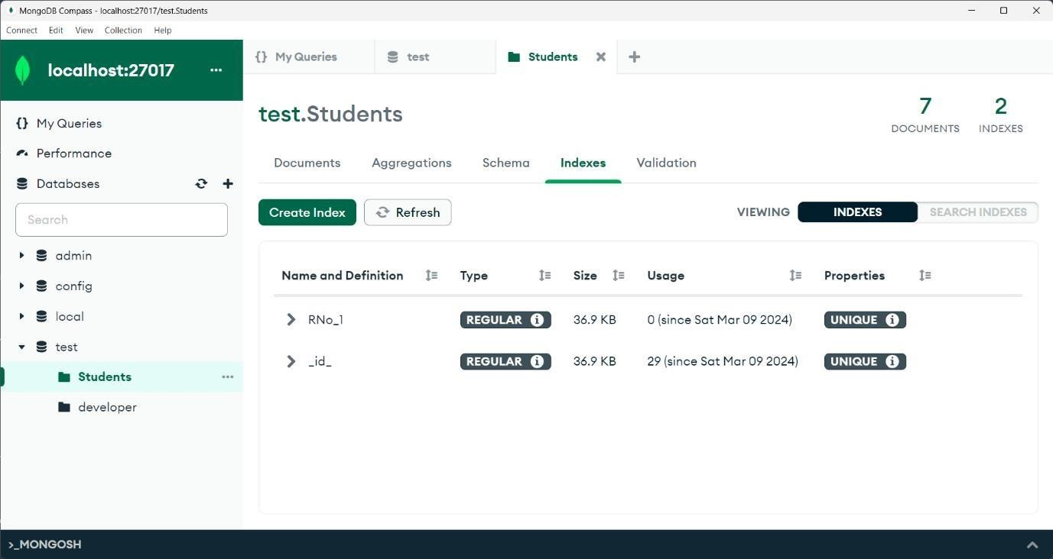

# Indexing usage:

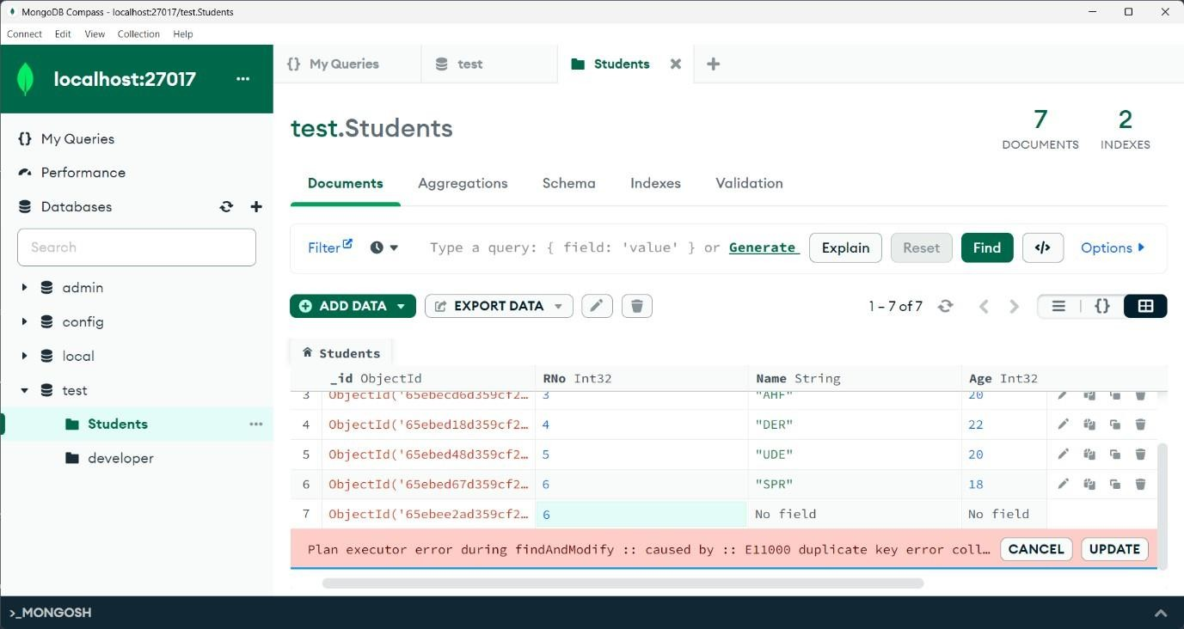As we gave rno as unique, if we try to insert a duplicate document that is existed it shows an error like. Duplicate collection.